

**J&T Banka Junior Grand Prix**

**Bratislava, Slovakia**

**19 – 22, August 2015**

**organized by the**

**Slovak Figure Skating Association**

**and the local organizing committee**

**Figure Skating Club Slovan Bratislava**

**FIRST INFORMATION**

**Region**

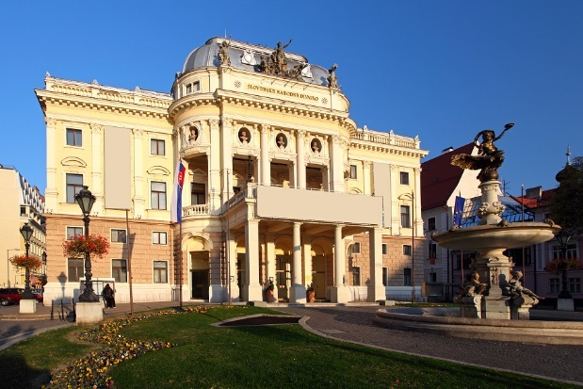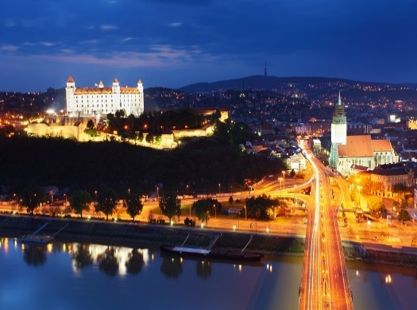Welcome to Bratislava. Ours is an old city, but one of Europe's newest capitals. As we hope you will see, it is big enough to have everything a visitor might want, but small enough to remain welcoming and unpretentious. Bratislava became a capital city when Slovakia became independent, in 1993. It has rapidly acquired the top-class hotels, restaurants and tourist facilities that reflect its status.  But the town's history goes back centuries, to pre-Roman times.  Successive waves of development as a major trading centre and, for almost 300 years, as the coronation city for the kings and queens of Hungary have blessed us with a fascinating blend of architecture and public spaces. The intimate old town, overlooked by the castle, is criss-crossed with narrow, traffic-free lanes and studded with mediaeval churches, Baroque palaces, small shops and fine cafes, bars and restaurants.  At its centre is the beautiful Old Town Square. Nearby, the unique New Bridge, built in the 1970s with its distinctive 'UFO' tower, spans the Danube River. On the right bank is central Europe's oldest public park, Sad Janka Krala, and next to it one of Bratislava's several modern shopping centres, Aupark. The city has a strong artistic tradition, with regular concert and opera performances at the Slovak National Theatre, and several outstanding galleries. Beyond the centre, Bratislava's superb position on the banks of the Danube and below the forested slopes of the Small Carpathian hills means a walk in the woods or a bicycle ride along the river are never more than a few minutes away.  Only slightly further afield are the wine towns of the Small Carpathians.  But any restaurant in the city will offer a range of local products, the fruit of our region's centuries-old winemaking tradition.

Bratislava is a safe, reasonably-priced destination that more and more visitors are now discovering.  We look forward to welcoming you too.

Enjoy your stay!

**Venue: 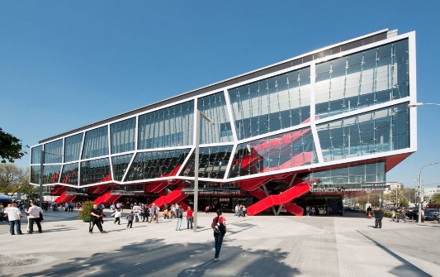Ondrej Nepela Ice Rink / Slovnaft arena**

The Stadium is named from 1991 in honour of Ondrej Nepela, Slovak figure skater who competed for Czechoslovakia in the late 1960s and early 1970s, and won Gold medal at the 1972 Winter Olympics in Sapporo, Japan.

It was one of the two hosting venues for the 2011 IIHF World Ice Hockey Championship.

In this year for 23rd time in a row, figure skaters from all over the world will compete at Ondrej Nepela Trophy, a senior level International competition listed in ISU Challenger Series. The venue will also host the ISU European Figure Skating Championships in January 2016.

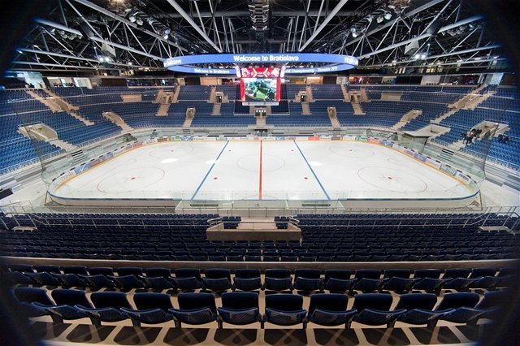A fully air-conditioned and heated ice rink of the size of 60m by 28m – the new Ondrej Nepela Arena ­offers a comfortable auditorium with 10,000 seats and convenient social and sanitary facilities, including the equipment for the disabled who can easily enter the auditorium on wheel-chairs. Visitors can be served in 2 restaurant and 4 cafeterias. This complex have got 2 practice ice rinks hall B 28 x 58m and hall A 26 x 56m.Ice rink complex has been opened in April, 2011.Temperature in the center of ice rink : air +15°C, ice –5°C.

**Climate**

The average outside temperature during the period concerned is +30° Celsius at day and +20° Celsius at night.

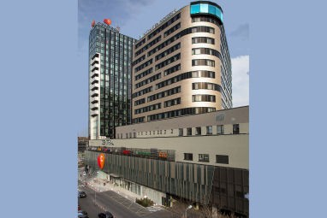**Hotels**

**Welcome to the Lindner Hotel Gallery Central!**

We would like to take this opportunity to inform you about the **SPECIAL rates** we have prepared in our newly opened 4* hotel in Bratislava for your venue during the dates 19.08.2015 – 23.08.2015.

Please find in this document the details of our proposal and come back to us if you are interested for this special offer. It would be a pleasure to welcome you and your guests at the Lindner Hotel Gallery Central, where you can expect the most spectacular views of the whole Bratislava! A total of 222 rooms, suites and first class rooms as well as handicapped accessible double rooms, all exuding a casually contemporary ambiance and most of them boasting a fantastic view of Bratislava Castle, await you at the Lindner Hotel Gallery Central. All the rooms placed between 13 floors have a bathroom with a shower or a bathtub, infra-red light in bathrooms, coffee & tea making facilities, hairdryer and make-up mirror, as well as a flat-screen TV, telephone, mini-bar and room safe. This is where you can switch off and relax in a refreshing ambiance. Wi-Fi connection is available free of charge. There are 2 beds in each room which we combine together for the single travellers so you can look forward to the comfort of the bed of 180 x 210cm! After the nice rest at night, you can enjoy your breakfast in the spacious restaurant Galler!a with a terrace overlooking a green park. There is no better place than Outlook Bar & Lounge, placed on the 13th floor, where you can have a drink or special meal overlooking the whole Bratislava, some days with live music!

**Lindner Hotel Gallery Central** (for Teams)

Metodova 4  
SK-82108 Bratislava  
phone: +421 2 3993 0000

web: <http://www.lindner.de/en/hotel_bratislava/>

Distance from the Ice rink: 250 m

Prices for accommodation per person and night including breakfast and local taxes per day

Double room - 46.00 € (per person)

Single room - 92.00 €

Parking price per day 5.00 €

Wellness Centre 5,50 € payment at reception desk

**Meals**

All the accredited Team Members, who will not receive meal-vouchers from the OC, can purchase them from the OC (either per meal or for a certain time period) for the following prices:

**Lunch or Dinner per meal: 15.00 €**

**HOTEL Double Tree by HILTON\*\*\*\***

(for ISU Event Officials and Judges)

Trnavska cesta 27/A

831 04 Bratislava

<http://doubletree3.hilton.com/en/hotels/slovakia/doubletree-by-hilton-hotel-bratislava-BTSDIDI/index.html>

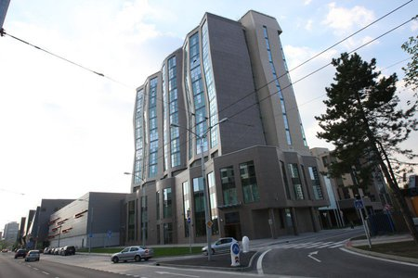Distance from Ice rink – one complex with Ice rink

Prices for accommodation per **room** and night including breakfast

Single room - standard class 85.00 €

Double room - standard class 100.00 €

Single room - de luxe 110.00 €

Double room - de luxe 120.00 €

Apartment junior 145.00 €

Municipality taxes of 1.60 € per person and night are not included

in the room rate.

Prices for meals: **Lunch or Dinner per meal 20.00 €**

**General Remarks for accommodation:**

**Competitors will be accommodated in twin-bed-rooms whenever possible. The hotel will not accept private booking orders. If a skater shares a room with a person from their team, the price is shared. If a Judge or an ISU Event Official shares a room with an accompanying person, he/she is obliged to pay the difference between the Single and Double Room. Accommodation can be booked only through the Organizing Committee.**

**Organizer provides the payment option for accommodation in advance to the following bank account:**

**Bank: J&T Banka, Bratislava, Slovakia**

**IBAN: SK658320 0000 001200090818**

**SWIFT/BIC: JTBPSKBA**

### Account no. 1200090818

**Bank code 8320**

All expenses for hotel not paid in advance, and payments for food, transport to and from Bratislava airport are to be paid in cash at the financial department of the organizing committee upon arrival.

Responsible person : Mrs. Pavla MAUEROVA (cell phone: +421 905 342 311).

**Please note:**

**If rooms officially ordered will be cancelled, even rooms paid by the OC, any cancellation fee the OC has to pay to the hotels will be invoiced to the respective member.**

**Travelling to Bratislava**

The capital of Slovakia is not difficult to reach. While making your travel arrangements, you can find the following recommendations useful.

**By plane:**

* **Bratislava Airport (BTS)**

Bratislava Airport is located about 10 minutes from the official hotel and the venue.

* **Vienna International Airport / Swechat Airport (VIE)**

Vienna International Airport is located about 55 km (60 minutes) from the official hotel and the venue.

**By train:**

* **Please use the main** Bratislava Railway Station

**By bus:**

* Please use Bratislava Bus Station – Mlynske Nivy

The organizing committee provides a shuttle bus upon arrival and departure for the teams.

The transportation fee from Bratislava Airport, railway Station Bratislava and Bus Station Bratislava is:

* **9.00 €** per person / one way and needs to be paid upon registration.

The transportation fee from the Vienna International Airport / Airport Schwechat is:

* **20.00 € per person / one way** and needs to be paid upon registration.

**Accreditation**

Accreditation as a Team Member will be given to all entered Judges, Competitors and one Team-Leader per participating team, one Coach per Competitor, a maximum of two Team Officials of ISU Members (including the Member President), provided that they are Council Members, Technical Committee Members or Members of the Head Office of their Federation and a maximum of two medical persons. Accreditation will only be granted to persons in those various functions if officially entered and named through their National Association. The ISU Member certifies with the signed entry form the indicated functions within the team of all team members. Any misuse of any function will be sanctioned by the ISU/OC.

Accreditation will be given to appointed ISU Event Officials, ISU Office Holders and Guests of Honour.

**Passports of the skaters have to be presented at the accreditation for verification!**

**Chaperones**

Officially entered chaperones (one per skater) will receive a practice permit to watch all practice sessions and need to buy an event ticket to be able to see the competition.

**The Organizing Committee**

|  |  |  |  |
| --- | --- | --- | --- |
| Director | BESTANDIG | Jozef | +421 905 504 040 |
| Head of OC | JÁNOŠOVÁ | Zuzana | +421 907 265 462 |
| Assistant of head of OC | KURTI | Csaba | +421 948 688663 |
| Media and marketing manager | POKORNÝ | Milan | +421 907 750 759 |
| Finance | MAUEROVÁ | Pavla | +421 905 342 311 |
| Doctor | VALOVIC |  |  |
| Fire | VALOVIC |  |  |
| Music | GAZO | Patrik |  |
| Photo | MITICKY | Stanislav |  |
| Announcer | HORNÁ | Janka |  |
|  | KADLECEK | Nikodem |  |
| Transport | KUSNIER | Stanislav | +421 905 849 392 |
| Accreditation | STANKOVIANSKA | Wanda | +421 903431 935 |
| Victory Ceremonies | VODOVÁ | Anna |  |
|  | VAJDIKOVÁ | Jana |  |
| Arena manager | BREZINA | Jozef |  |
| Technical | MOLNÁR | Attila |  |
|  | STANKOVIANSKA | Wanda |  |
| Cube of arena | BALAJKA | Juraj |  |
| Information hotels | KOVAČIČOVÁ | Zuzana |  |
|  | reception of hotel |  |  |
| Information ice rink | KURTI | Csaba |  |
| Catering | BESTANDIGOVÁ | Oľga |  |
|  | MARCELOVÁ | Zuzana |  |
| Security | EAGLE SECURITY |  |  |

**Other information**

Hotel LINDNER Bratislava reception +421 2 3993 0000

Hotel Double Tree by HILTON reception +421 2 3234 0111

Bratislava airport info [information@airportbratislava.sk](mailto:information@airportbratislava.sk) +421 2 330 33 353

Bratislava train info +421 2 202 97 538

**Useful information Currency : 1 EUR**

Exchange rates:

EUR 1 = app. 1,10 USD

EUR 1 = app 1,03 CHF

EUR 1 = app 0,71 GBP

EUR 1 = app 1,40 AUD

EUR 1 = app 27,37 CZK

EUR 1 = app 133,39 JPY

**Banks :** Usually open from 09.00 to 17.00 (Monday – Friday)

**Electricity:** Electricity sockets are 220 V, AC 50 Hz, using three-pin plugs

**The Organizing Committee can be contacted as follows:**

Figure Skating Club Slovan Bratislava

Ružinovská 4

821 01 Bratislava

Slovak Republic

Fax: +421 232 201 176

Email: [jgpbratislava@gmail.com](mailto:jgpbratislava@gmail.com)

Web: [www.bratislava.sk](http://www.bratislava.sk)

Ticket: [www.ticketportal.sk](http://www.ticketportal.sk)

**Preliminary Time Schedule**

|  |  |  |  |
| --- | --- | --- | --- |
| **Tuesday,**  **August 18, 2015** | All day | Arrival of teams |  |
|  | From 12:00 | Accreditation | Ice Rink |
|  |  |  |  |
| **Wednesday,**  **August 19, 2015** | All day | Official practice |  |
| 13:00 | Team Leaders Meeting | Ice Rink |
| TBA | Individual Technical Panel Meetings per Discipline | Ice Rink |
| 17:00 | Referees and Technical Controllers Meeting | Hotel Hilton |
| 18:00 | Judges Draw and Meeting | Hotel Hilton |
|  | 21:00 | Reception of the City of Bratislava for  ISU Officials and Judges |  |
|  | | |  |
| **Thursday,**  **August 20, 2015** | 13:00 | LADIES – Short Program |  |
|  | ICE DANCE – Short Dance |  |
|  | | |  |
| **Friday,**  **August 21, 2015** | 13:00 | MEN – Short Program |  |
|  | LADIES – Free Skating |  |
|  | Victory Ceremony LADIES |  |
|  | | |  |
| **Saturday,**  **August 22, 2015** | 08:00 | LADIES – Technical Panel Review |  |
| 09:00 | LADIES – Round Table Discussion for Judges |  |
| 12:15 | ICE DANCE – Free Dance |  |
|  | MEN – Free Skating |  |
| 15:30 | ICE DANCE - Technical Panel Review |  |
|  | Victory Ceremonies ICE DANCE and MEN |  |
| 19:00 | MEN - Technical Panel Review |  |
| 19:00 | ICE DANCE – Round Table Discussion for Judges |  |
| 20:30 | MEN – Round Table Discussion for Judges |  |

**Please note:**

**This schedule is subject to changes and will be updated in accordance with the final number of entries.**